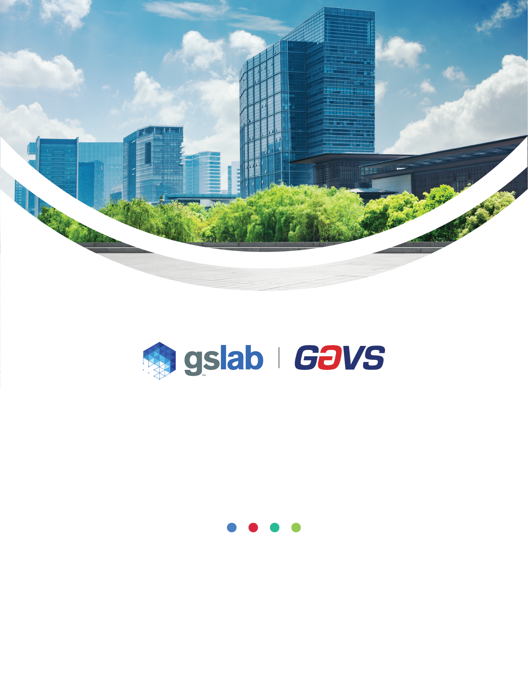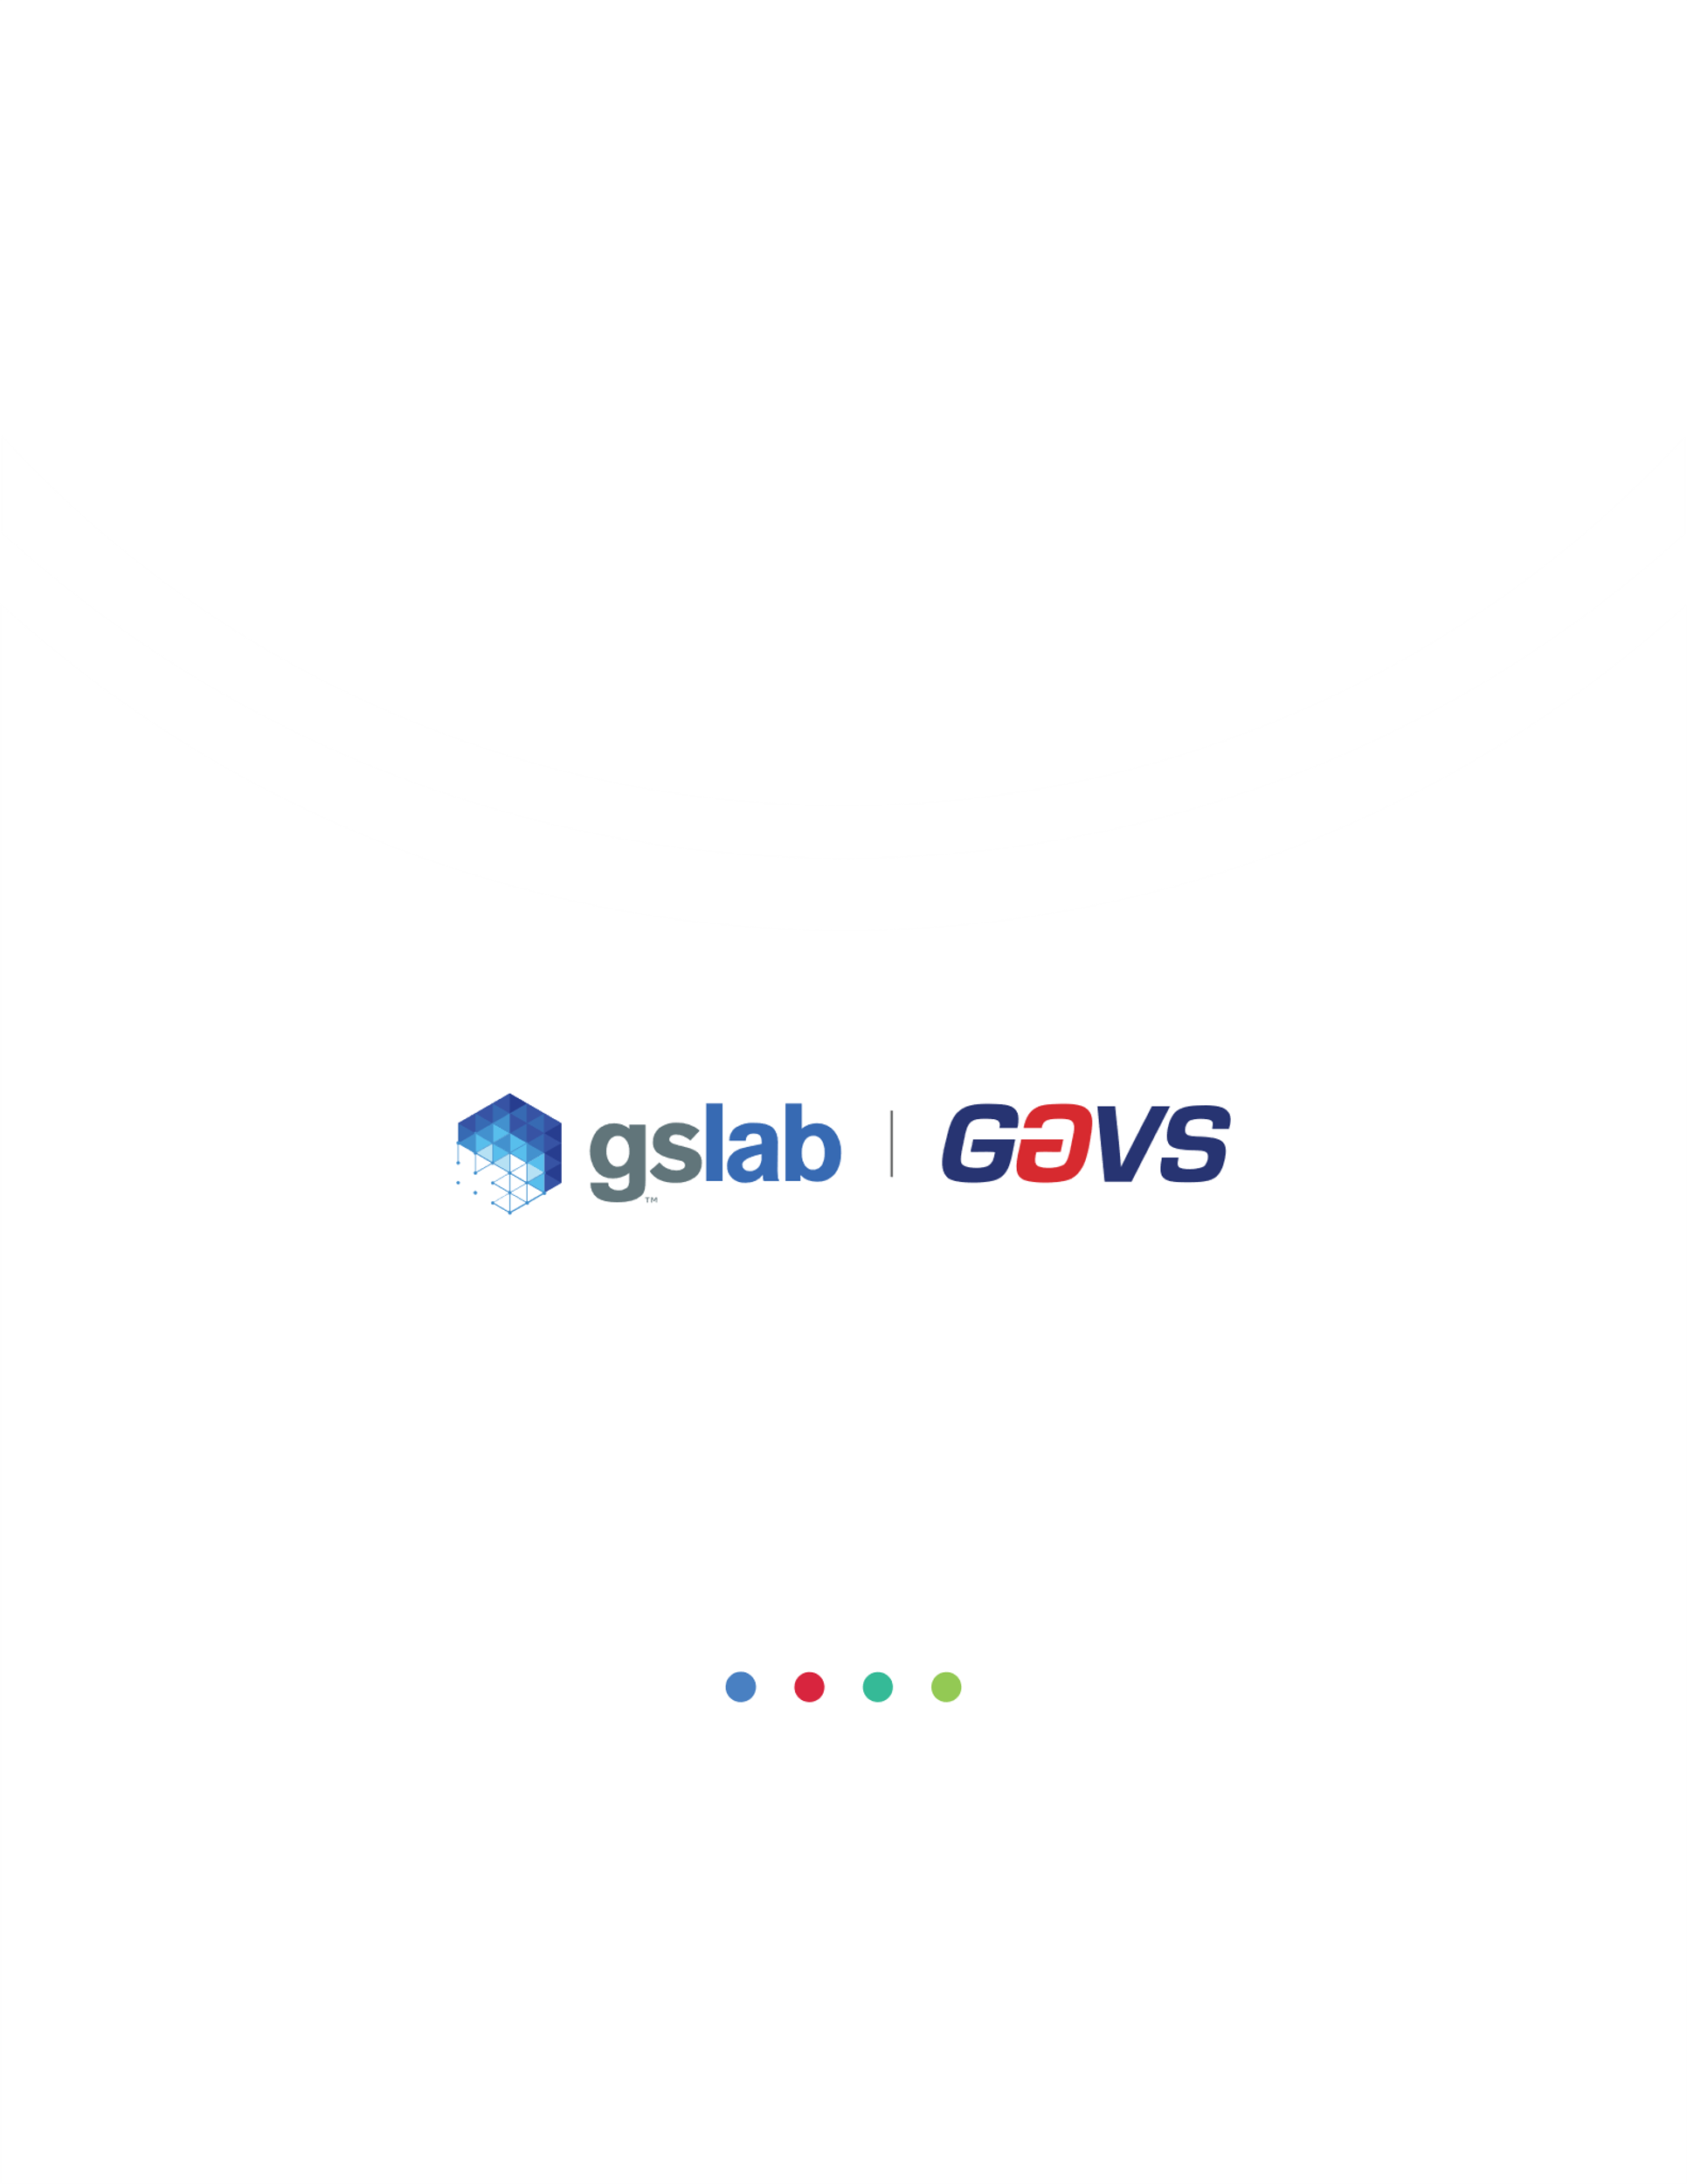

**Availability & Capacity Management**

Policy Template

Customer Name

Author Name: Gouri Mahendru

Version: 2.1

Document History

|  |  |  |  |  |
| --- | --- | --- | --- | --- |
| Version | Date | Summary of Changes | Author | Approved By |
| 1.0 | 10-Apr-14 | Initial Document | Sujatha | Sekar T |
| 1.01 | 1-May-17 | Change GAVS logo | Emmanuel F | Sekar T |
| 2.0 | 20-Jan-23 | Revised Policy Statements (section 5.0) | Gouri Mahendru | Sekar T |
| 2.1 | 16-Mar-23 | Updated as per new GS Lab | GAVS document format | Gouri Mahendru | Sekar T |

|  |
| --- |
| Statement of Confidentiality |
| This GS Lab (Great Software Laboratory) and/or GAVS (GAVS Technologies) artefact and/or document and/or presentation is strictly confidential. It contains proprietary information intended only for recipients.  The recipient acknowledges and agrees that: (i) this artefact and/or document is not intended to be distributed ii) the recipient does not have the right to implement, copy, reproduce, fax, publicly divulge, or further distribute it, in whole or in part in any form, without seeking the express written permission from GS Lab and GAVS.  Any unauthorized use of the contents of this artefact and/or document and/or presentation in any manner whatsoever, is strictly prohibited. The artefact and/or document and/or presentation represents GS Lab’s and/ or GAVS’s current product offerings and best practices which are subject to change without notice. Please note that GS Lab and GAVS collaborate in relation to some of its offerings.  All third-party trademarks used herein belong to their respective owners and may be protected by law. This artefact and/or document and/or presentation only refers to such trademarks under the doctrines of nominative and descriptive fair usage to illustrate and explain concepts without implying violation of any legal constraints. If improper activity is suspected, all available information may be used by GS Lab and /or GAVS for any remedy or for lawful purpose. |

Table of Contents

**1.** **Purpose** 4

**2.** **Scope** 4

**3.** **Definitions** 4

**4.** **Applicable Laws, Regulations, and Industry Standards** 4

**5.** **Policy Statements** 4

**6.** **Non-compliance** 5

## **Purpose**

Describe the factors or circumstances that mandate the existence of the policy. Also state the policy’s basic objectives and what the policy is meant to achieve.

* The purpose of this policy is to enable [Company Name] to balance system availability and capacity requirements with cost-to-serve realities. The policy mandates periodic and ad hoc activities to assess availability and capacity against requirements and prioritize cost-effective investment based on business impact.

## **Scope**

Define to whom and to what systems this policy applies. List the employees required to comply or simply indicate “all” if all must comply. Also indicate any exclusions or exceptions that are out of scope, i.e. those people, elements, or situations that are not covered by this policy or where special consideration may be made.

This policy applies to all business processes and data, information systems and components, personnel, and physical areas of [Client Name]. Person(s) this policy applies to include but are not limited to:

* Executives, Vice Presidents, and Directors

All employees, whether employed on a full-time or part-time basis by [Client Name]

## **Definitions**

Define any key terms, acronyms, or concepts that will be used in the policy or accompanying procedures. A standard glossary approach is sufficient. An example definition:

Authorized Individuals: Organizational personnel, contractors, or any other individuals with authorized access to the information system in which the organization has the authority to impose rules of behavior with regard to system access.

## **Applicable Laws, Regulations, and Industry Standards**

If applicable, list any laws or regulations that govern the policy or with which the policy must comply. Confirm with the legal department that the list is full and accurate. If there are no applicable laws, regulations, or industry standards delete this section.

|  |  |
| --- | --- |
| Guidance | Section |
| ISO 20000-1:2018 | Section 8.7 (Service Assurance – Availability Management) |

## **Policy Statements**

Describe the rules that comprise the policy. This typically takes the form of a series of short prescriptive and proscriptive statements. Subdividing this section into subsections may be preferable, depending on the length or complexity of the policy.

**Foundational Policy Requirements:**

* [Client Name] will strike a balance between between cost-to-serve and system availability and capacity requirements.

**Derived Policy Requirements:**

* A capacity plan will be submitted as part of the change management process.
* Baseline capacity requirements will be validated via ongoing systems monitoring.
* Monitoring data will be reviewed every [time period] to identify availability, performance, and capacity issues and recommend mitigations where appropriate.
* Investments to improve performance, availability, and capacity will be prioritized based on a business impact analysis (BIA).

## **Non-compliance**

Clearly describe consequences (legal and/or disciplinary) for employee noncompliance with the policy. It may be pertinent to describe the escalation process for repeated noncompliance.

Violations of this policy will be treated like other allegations of wrongdoing at [Client Name]. Allegations of misconduct will be adjudicated according to established procedures. Sanctions for noncompliance may include, but are not limited to, one or more of the following:

1. Disciplinary action according to applicable [Client Name] policies
2. Termination of employment
3. Legal action according to applicable laws and contractual agreements